Why Cloud?

* Multi-Tenant
* Self service
* Elastic – Scale up/Scale-down
* Web based
* Automated
* Pay as you go model
* Modern web based integration
* Secure
* **Infrastructure-as-a-Service (IaaS)**: It provides a hardware platform as a service.
* **Platform-as-a-Service (PaaS)**: It provides end-users an application development environment delivered over the internet.
* **Software-as-a-Service (SaaS)**: It provides end-users a standardized, network-delivered IT applications.

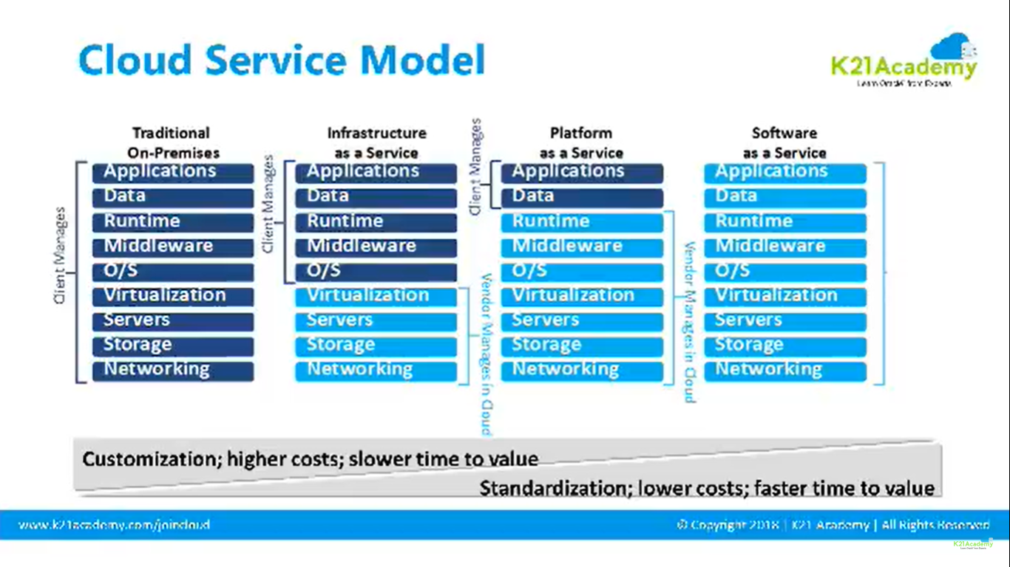

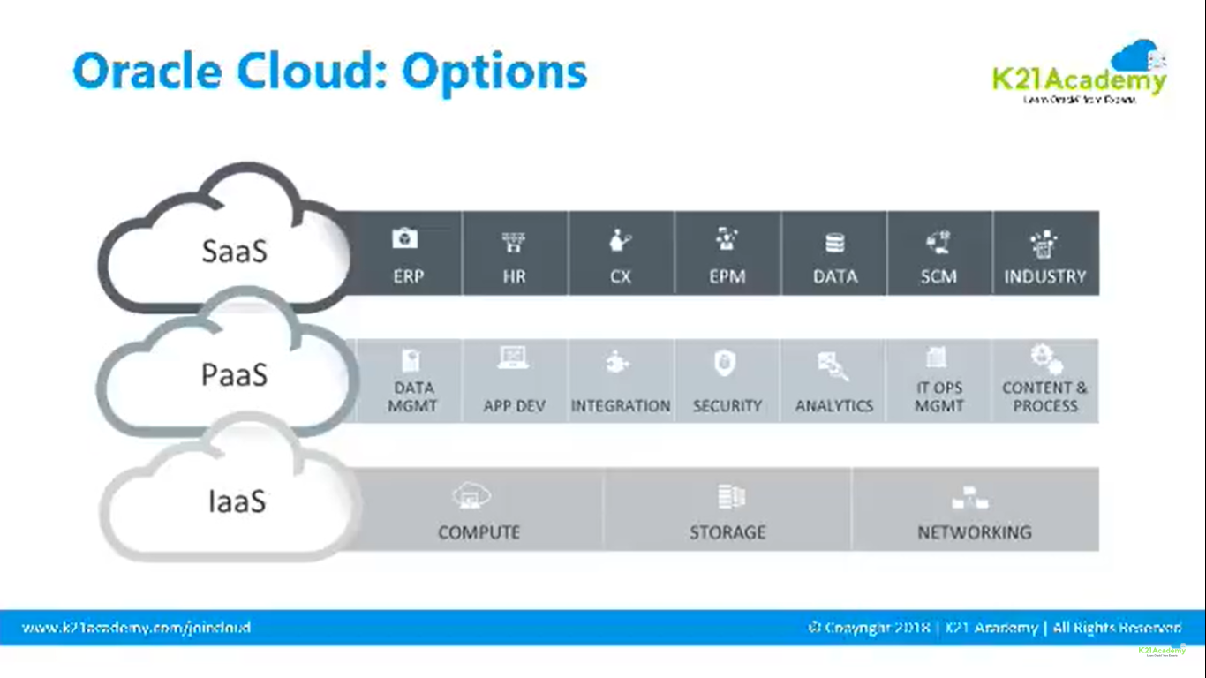

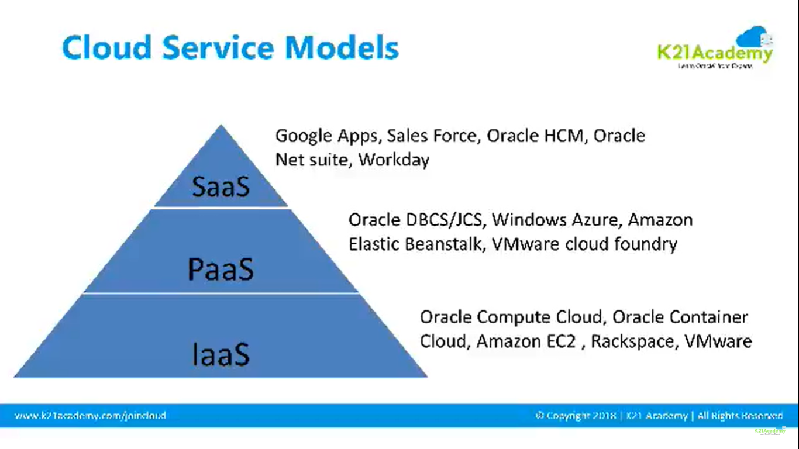

1. **Infrastructure as a Service [PaaS]**

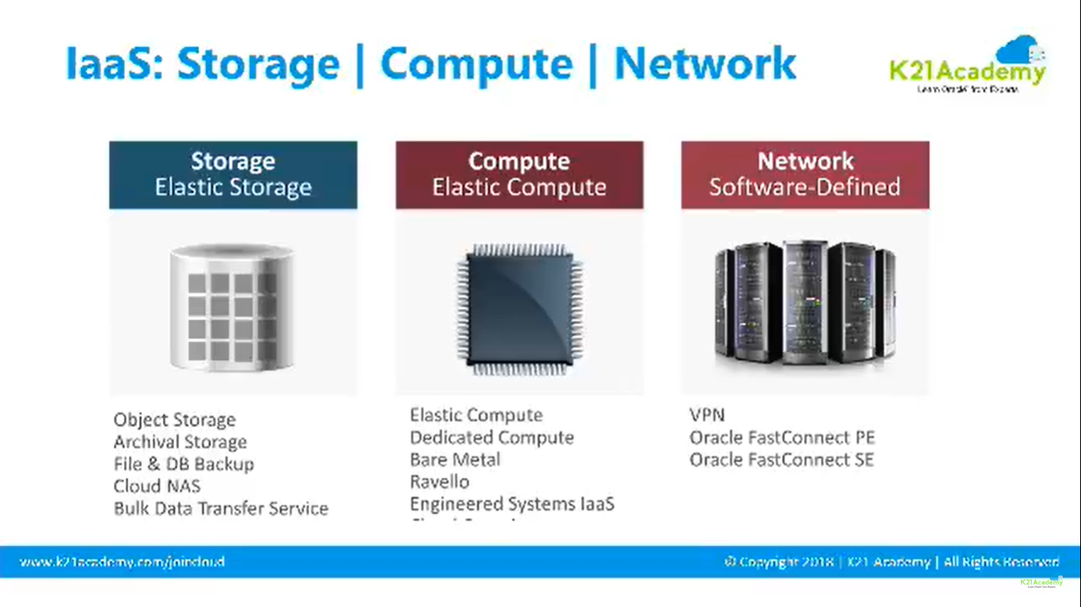

1. **Platform as a Service [PaaS]**

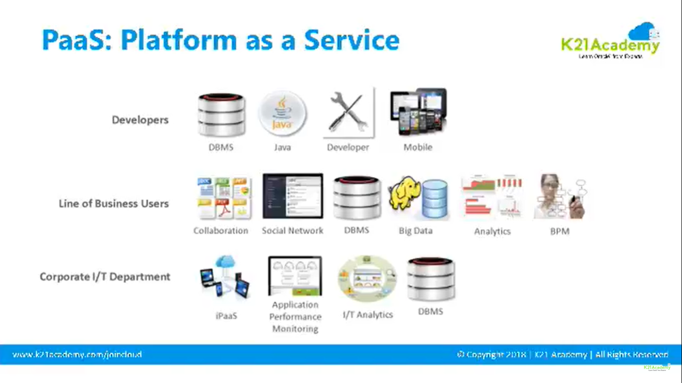

**Oracle offerings in PaaS**

**DBCS – Database cloud service**

* Provides ability to deploy Oracle databases in the cloud with each database deployment containing a single oracle database.
* Full access to features and operations.

**JCS – Java Cloud Service**

* PaaS solution to build, deploy and manage Java EE application.
* JCA contain
  + Weblogic server – Application container
  + Coherence for catching and data grid
  + Oracle Traffic director for software load balancing
* Runs on Oracle Compute Service
* Automated provision,path,manage – Weblogic, Coherence and OTD

**SAOCS – SOA Cloud Service**

* Running the Oracle SAO suite and SOA applications in the cloud.
* Develop, deploy and manage SOA composites and applications.
* OSB
* Oracle API manager
* BAM
* MFT

Provides access to cloud adapters like salesforce, On-Premise adapters like SAP and EBS and technology adapter like FTP, AQ JMS etc. You can quickly create dev and test evn in Oracle SOA Cloud Service. You can move your existing workloads to Oracle SOA Cloud.

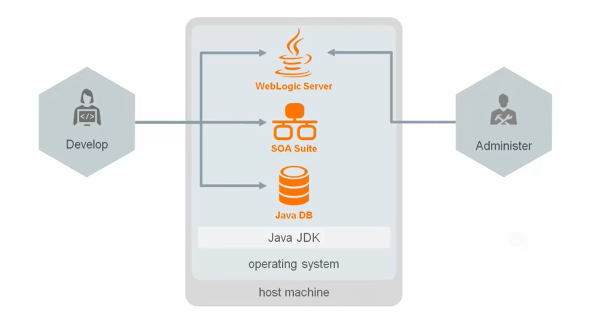

**IDCS – Identity Cloud Service**

* Identity access management
* Identity governance for application
* Single sign on

**ICS – Integration Cloud Service**

* Designed for SaaS
* Integrate cloud apps
* Integrate cloud with On-Premise
* Pre-Built integrations for common scenarios
* Automated provision, backup, Patch and upgrade

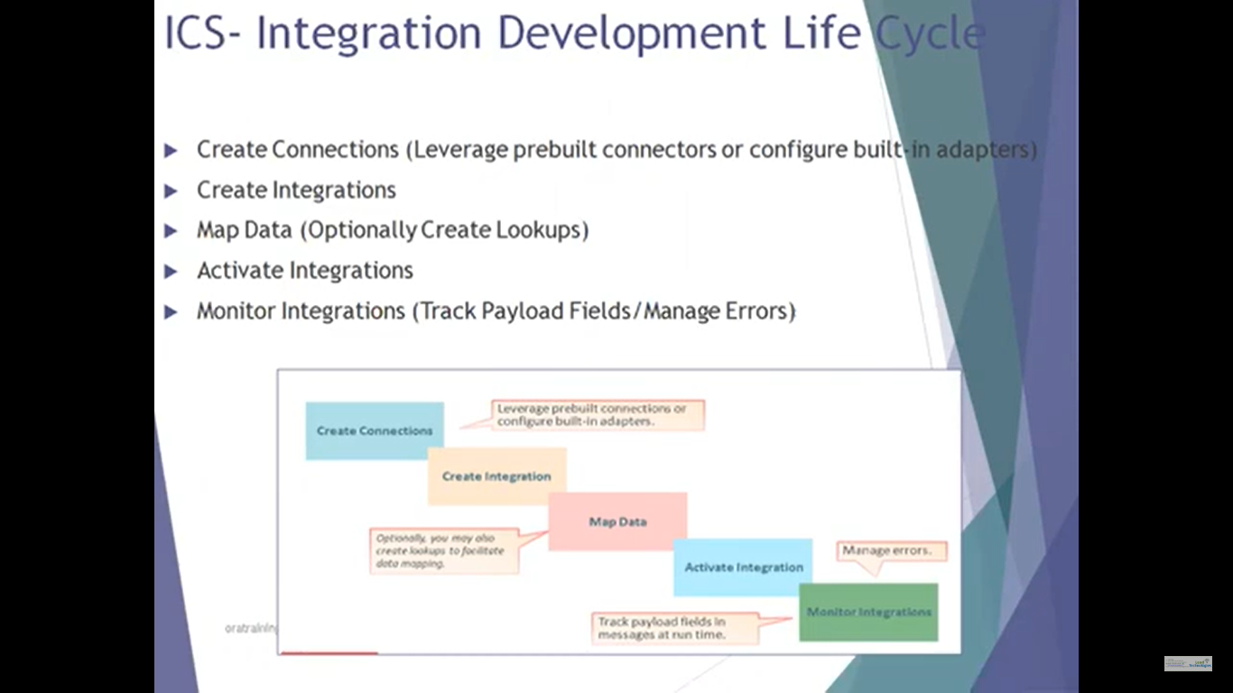

1. **Software as a Service**

